14.49: a) At 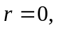the model predicts 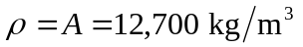and at 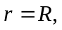the model predicts
b), c)
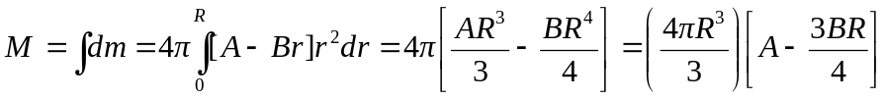
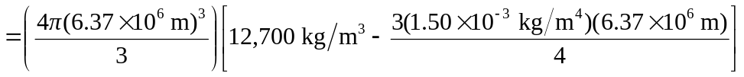
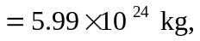

which is within 0.36% of the earth’s mass. d) If 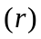is used to denote the mass contained in a sphere of radius 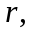 then 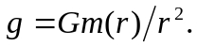 Using the same integration as that in part (b), with an upper limit of instead of  gives the result.

e)
f) 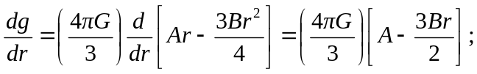

setting ths equal to zero gives 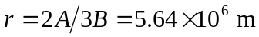, and at this radius
